Assignment2 Report
Platform (Colab/Kaggle/Local): Colab
Python version: Colab
Operating system: Colab
CPU: Colab
GPU: Colab
Remark: For ease of grading, you are encouraged to present data in textual form rather than as images.
Present your hyper-parameters in training, including learning rate, batch size, hidden size, epochs(steps), etc. (5%)
Answer: learning rate = 0.001, batch size = 64, hidden size = 256, epochs = 3, embedding size = 256, clip value = 1
If you use RNN or GRU instead of LSTM, what will happen to the quality of your answer generation? Why? (10%)
Answer:
Use the same hyperparameter settings as shown below.
Hyper parameters | Learning rate | Batch size | Hidden size | epochs | Embedding size | Clip value
 | 0.001 | 64 | 256 | 2 | 256 | 1

The training logs and evaluation accuracy of the LSTM model are shown below.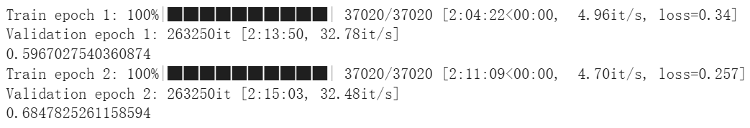
The training logs and evaluation accuracy of the GNU model are shown below.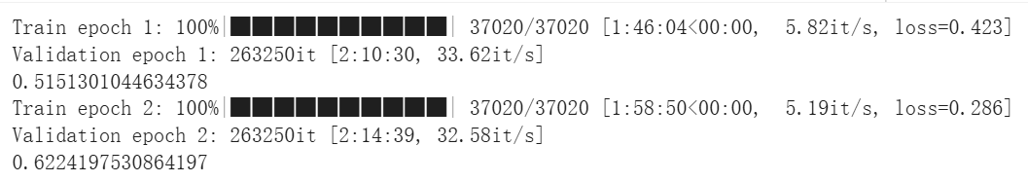
In terms of architecture, the GRU lacks the forget gate compared to the LSTM. As a result, it has fewer parameters and can be regarded as a simplified version of the LSTM, which makes its training faster. However, the GRU replaces the LSTM’s forget and input gates with a single update gate, and it merges the cell state and hidden state into one. Because of this design, the GRU has weaker long-term memory capability than the LSTM. Therefore, under the same training conditions, the accuracy of the GRU is usually lower than that of the LSTM.
Reference: https://medium.com/@prudhviraju.srivatsavaya/lstm-vs-gru-c1209b8ecb5a
If we construct an training set using three-digit numbers while the evaluation set is constructed from two-digit numbers, what will happen to the quality of your answer generation? (10%)
Answer:
Use the same hyperparameter settings as shown below.
Hyper parameters | Learning rate | Batch size | Hidden size | epochs | Embedding size | Clip value
 | 0.001 | 64 | 256 | 2 | 256 | 1

The training logs and evaluation accuracy of the original LSTM model are shown below.
I constructed a new training set using three-digit numbers (from 100 to 999), while the evaluation set remained the same as the original model, which contains two-digit numbers (from 0 to 99). Five examples of the three-digit training data are shown below.
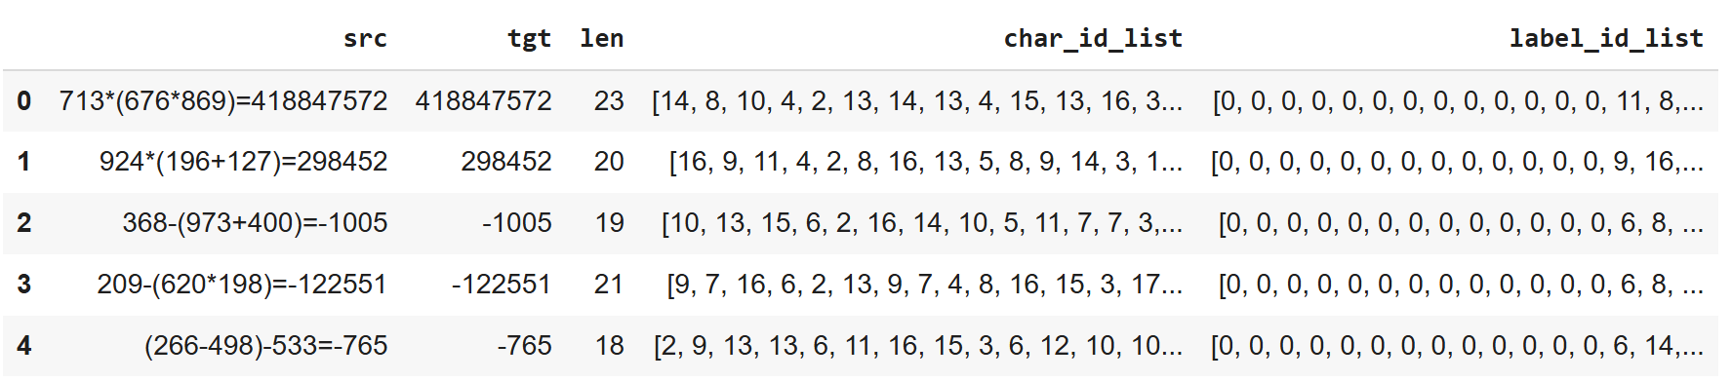
The training logs and evaluation accuracy of the LSTM model trained with this three-digit dataset are shown below.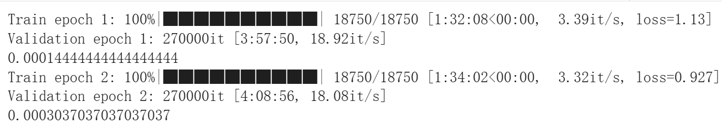
We can observe that training the model on three-digit numbers but evaluating it on two-digit numbers results in a much higher loss and significantly lower accuracy. This happens because the model learns to generate arithmetic patterns that are specific to three-digit inputs. When it encounters shorter two-digit numbers during evaluation, the learned representations no longer align well with the input distribution. Moreover, since the LSTM predicts the next token based on the previous sequence, longer operands may change the internal state patterns and make it harder for the model to correctly predict two-digit arithmetic expressions.
If we construct a training set that includes 20% incorrect answers, how will this affect the quality of the generated responses? Present some examples. (10%)
Answer:
Use the same hyperparameter settings as shown below.
Hyper parameters | Learning rate | Batch size | Hidden size | epochs | Embedding size | Clip value
 | 0.001 | 64 | 256 | 2 | 256 | 1

The training logs and evaluation accuracy of the original LSTM model are shown below.
I randomly modified 20% of the original training data by replacing the correct answers with incorrect ones to train another model. Five examples of the modified data are shown below.
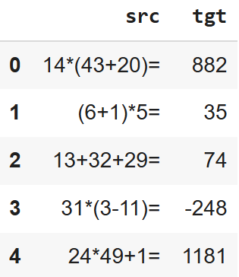
The training logs and evaluation accuracy of the LSTM model trained with the dataset containing 20% incorrect answers are shown below.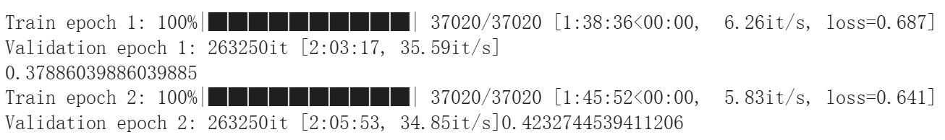
We can observe that this modification leads to higher loss and lower accuracy compared to the original model. Using the same number of epochs, the modified model fails to achieve high accuracy because the incorrect answers degrade the model’s learning quality and make the model learn wrong mappings between arithmetic expressions and their results.
Why do we need gradient clipping during training? (5%)
Answer: When training deep models such as multi-layer RNNs, gradients can sometimes grow uncontrollably (exploding gradients). This causes sudden spikes in loss and unstable training. Gradient clipping acts as a safeguard by capping the gradients at a predefined threshold, preventing extreme updates to model parameters. It keeps the training stable without hindering learning progress. If you observe large oscillations or divergence during training, gradient clipping is often an effective remedy.
Reference: https://medium.com/biased-algorithms/guide-to-gradient-clipping-in-pytorch-f1db24ea08a2
… Anything that can strengthen your report. (5%)
Answer:
I collected the incorrect predictions from the evaluation set and found 82,981 wrong generations out of 829,810 samples. To further understand why the model produced incorrect results, I analyzed 106,168 wrong generations and categorized them into four groups:
- Whether parentheses are present or not
- Whether mixed operators are used (e.g., containing both “+” and “*”)
- Containing three or more operators
- Others
The proportions of each category are 58.1%, 28.1%, 12.2%, and 1.6%, respectively. This analysis suggests that expressions involving parentheses or mixed operators are the most challenging cases for the arithmetic model to learn correctly.
In addition, I also collected the incorrect predictions from the three-digit model. The evaluation results and ground truths of the LSTM model trained on the three-digit dataset are shown below.
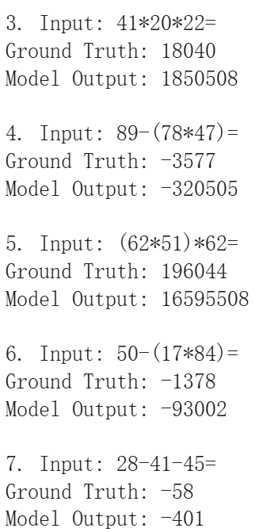
We can observe that the model trained on three-digit numbers tends to generate longer outputs than the ground truth. This finding verifies that, since the LSTM predicts the next token based on the previous sequence, longer operands may change the internal state patterns and make it harder for the model to correctly predict two-digit arithmetic expressions.
The screenshot of your training logs and evaluation accuracy. (One Figure only) (10%)


